WEBTECHNOLOGY PROJECT

ONLINE CAB BOOKING SYSTEM

The project is about the development of an interactive website which functions as a Cab Booking System for customers to effortlessly book cabs for travel, the system is named PSR CABS. It is an online portal through which customers can view available cabs, register the cabs, view profile and book cabs

Standard Web development languages like HTML, JAVA were used for Front-end and Back-end development respectively

MODULES FOR ADMIN:

* VEHICLE
* DRIVER
* ROUTE

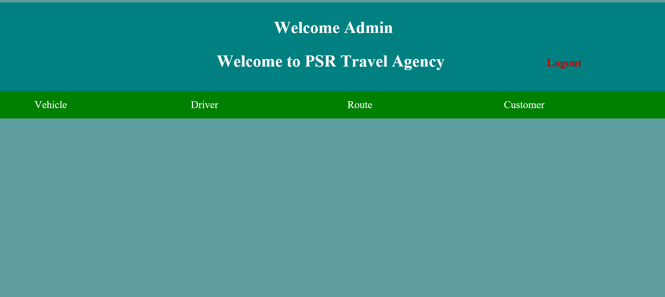

VEHICLE:

* + ADD DRIVER
  + ADD ROUTE
  + ADD VEHICLE
  + BOOKING HISTORY
  + CUSTOMER BOOKING HOSTORY
  + DELETE DRIVER
  + DELETE ROUTE
  + DELETE VEHICLE
  + DISPLAY ALL DRIVER
  + MODIFY DRIVER
  + MODIFY ROUTE
  + MODIFY VEHICLE
  + SEARCH RESULT

ADDING VEHICLE DETAILS: 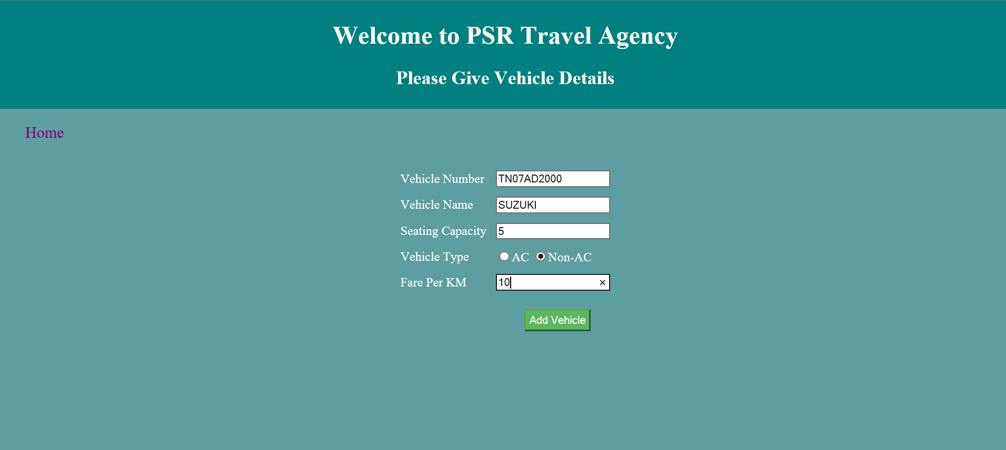

ADDING DRIVER DETAILS:

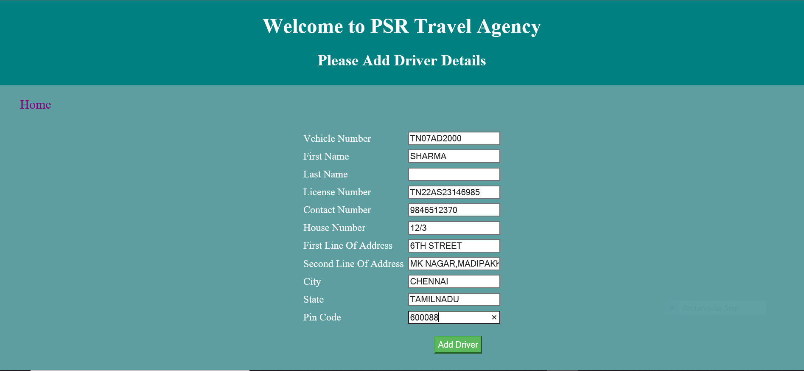

DELETING DRIVER DETAILS

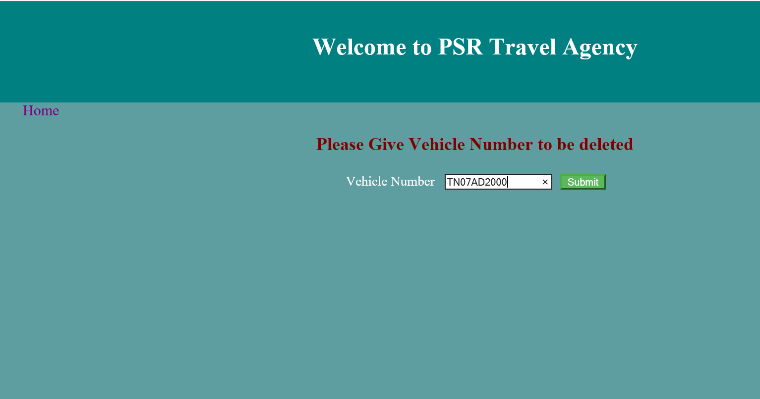

ADDING ROUTE

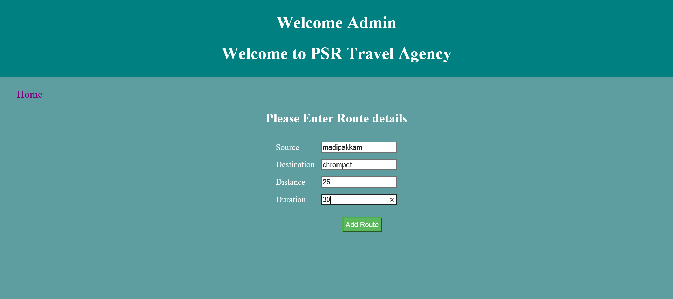

DELETING ROUTE: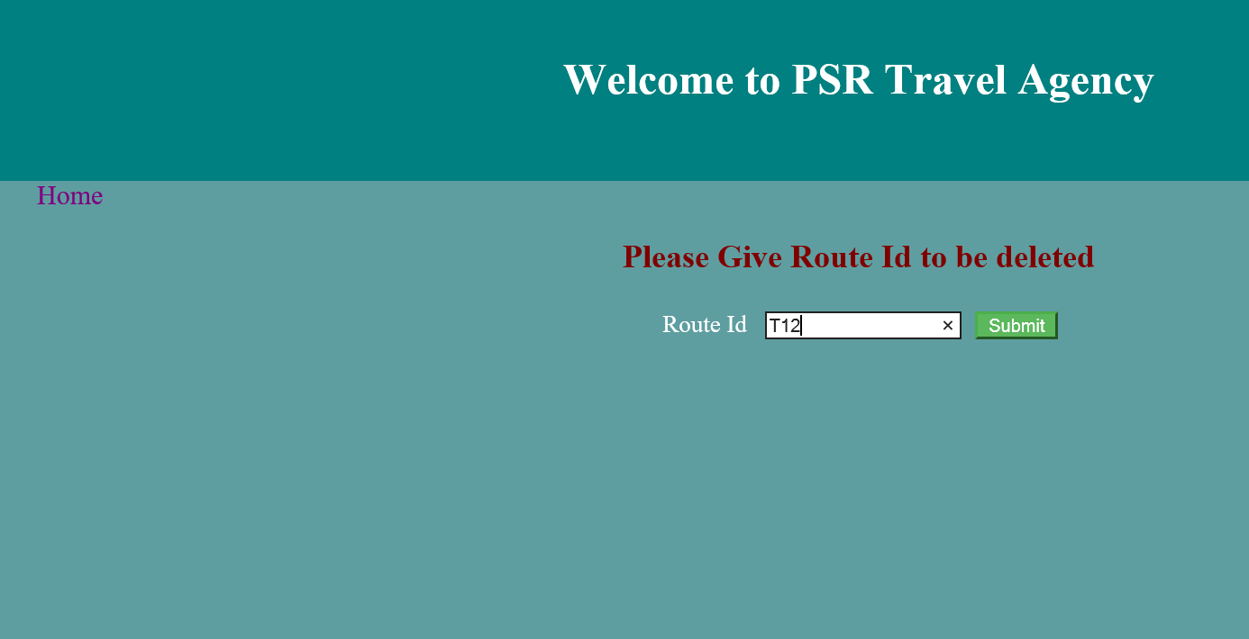

CUSTOMER MODULE:

* + BOOK VEHICLE
  + CANCELLATION
  + LOGIN
  + REGISTER
  + GATEWAY
  + PAYMENT
  + PAYMENT SUCCESS
  + PRINT TICKET
  + VIEW VEHICLE

LOGIN:

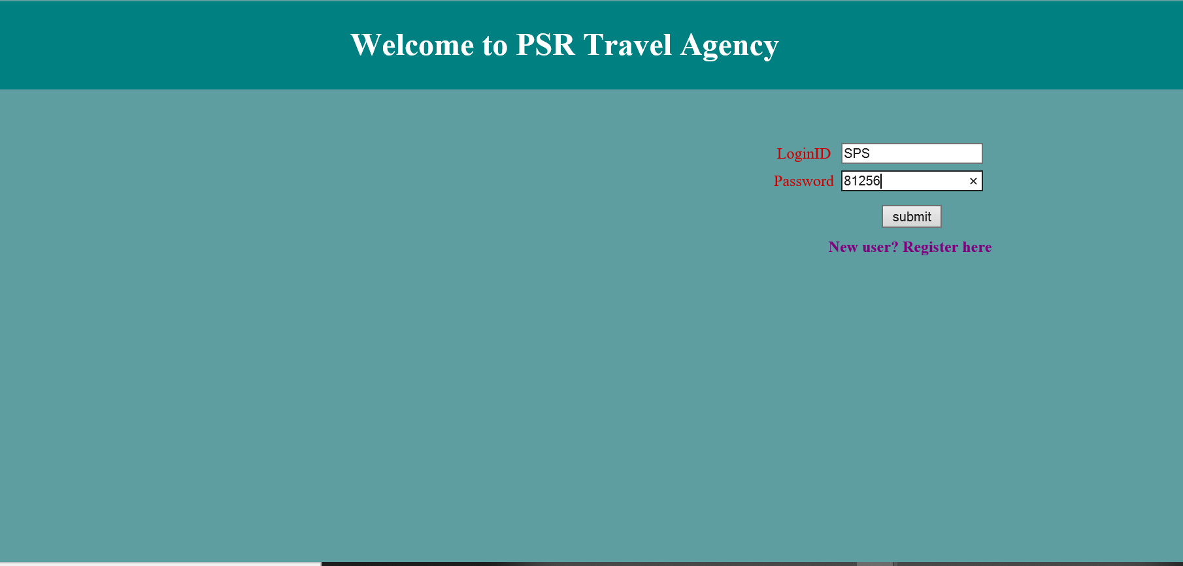

REGISTER:

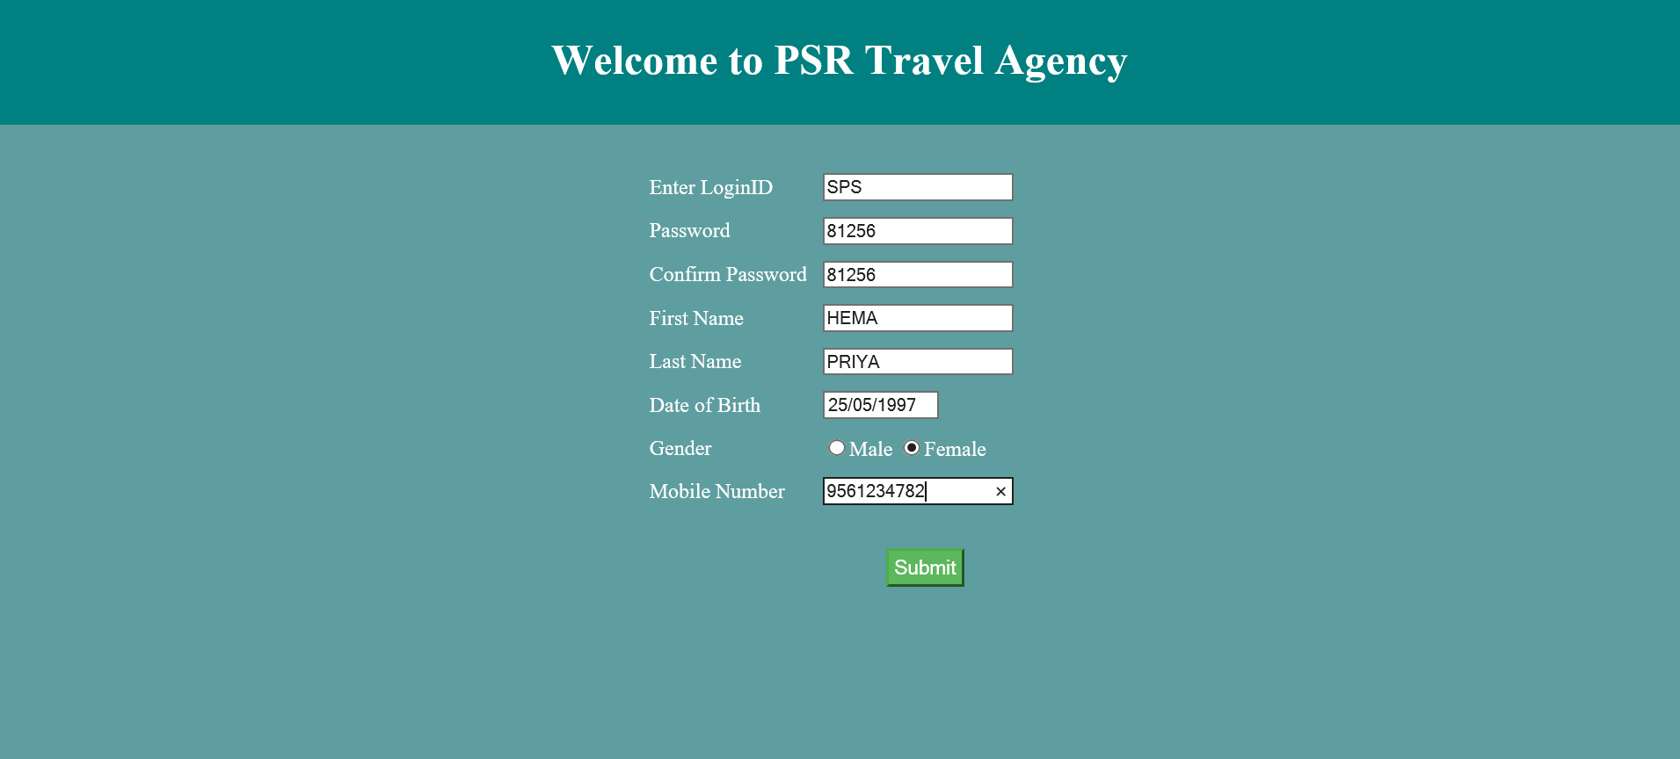

PAYMENT:

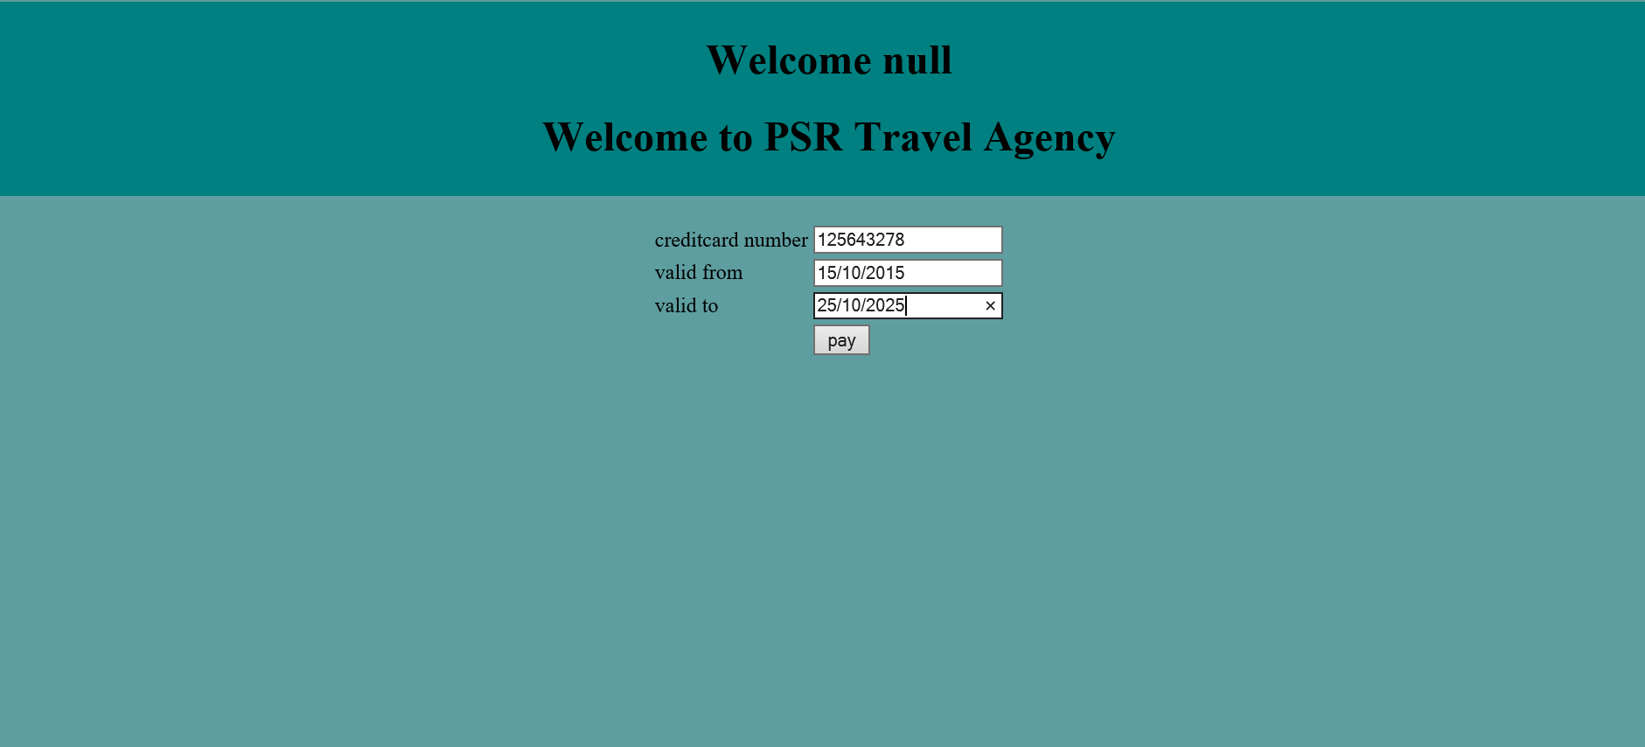

PAYMENT SUCCESS:

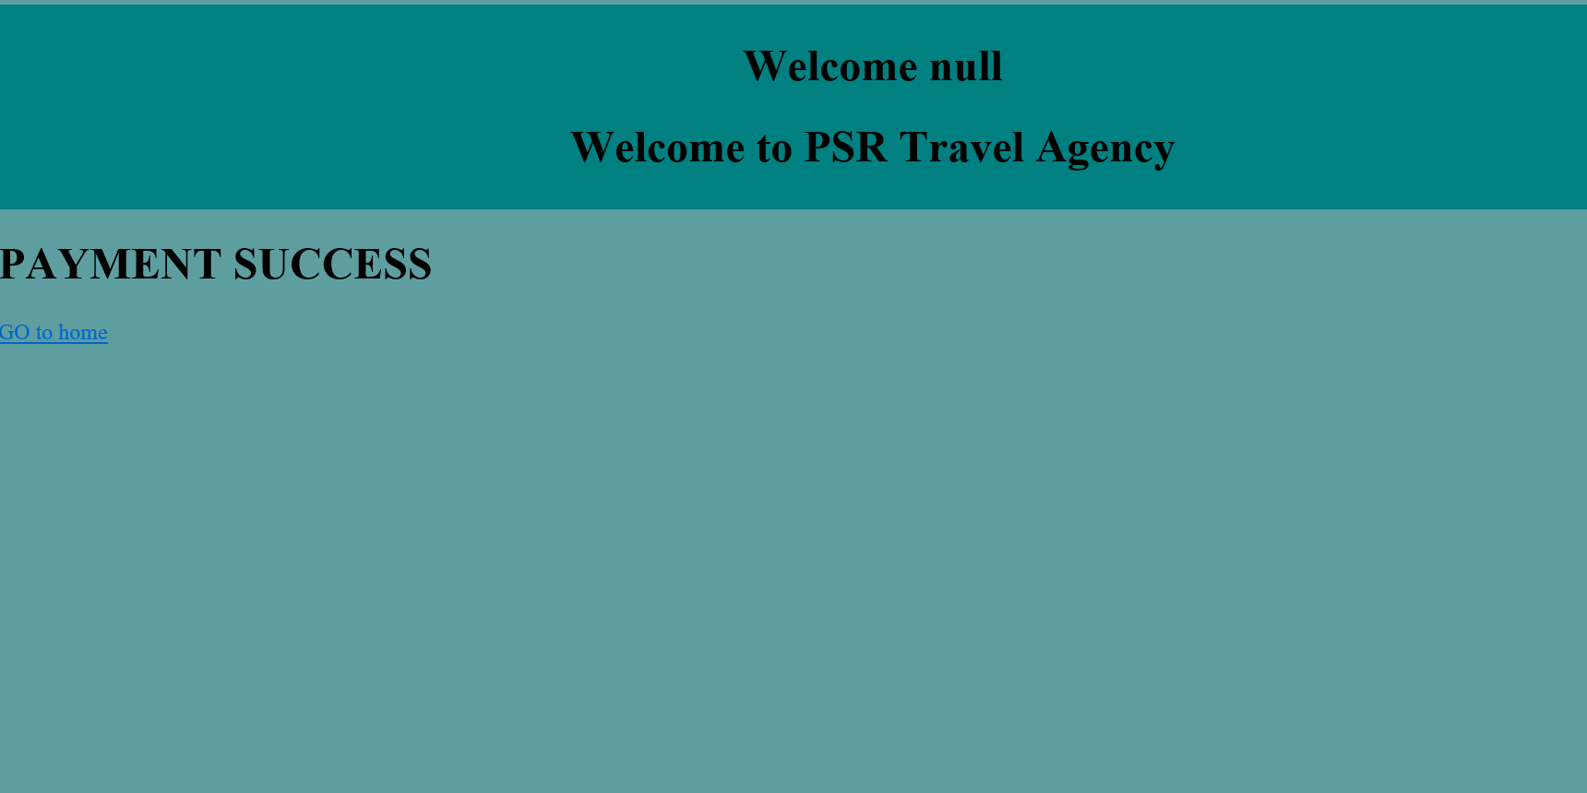

PRINT TICKET: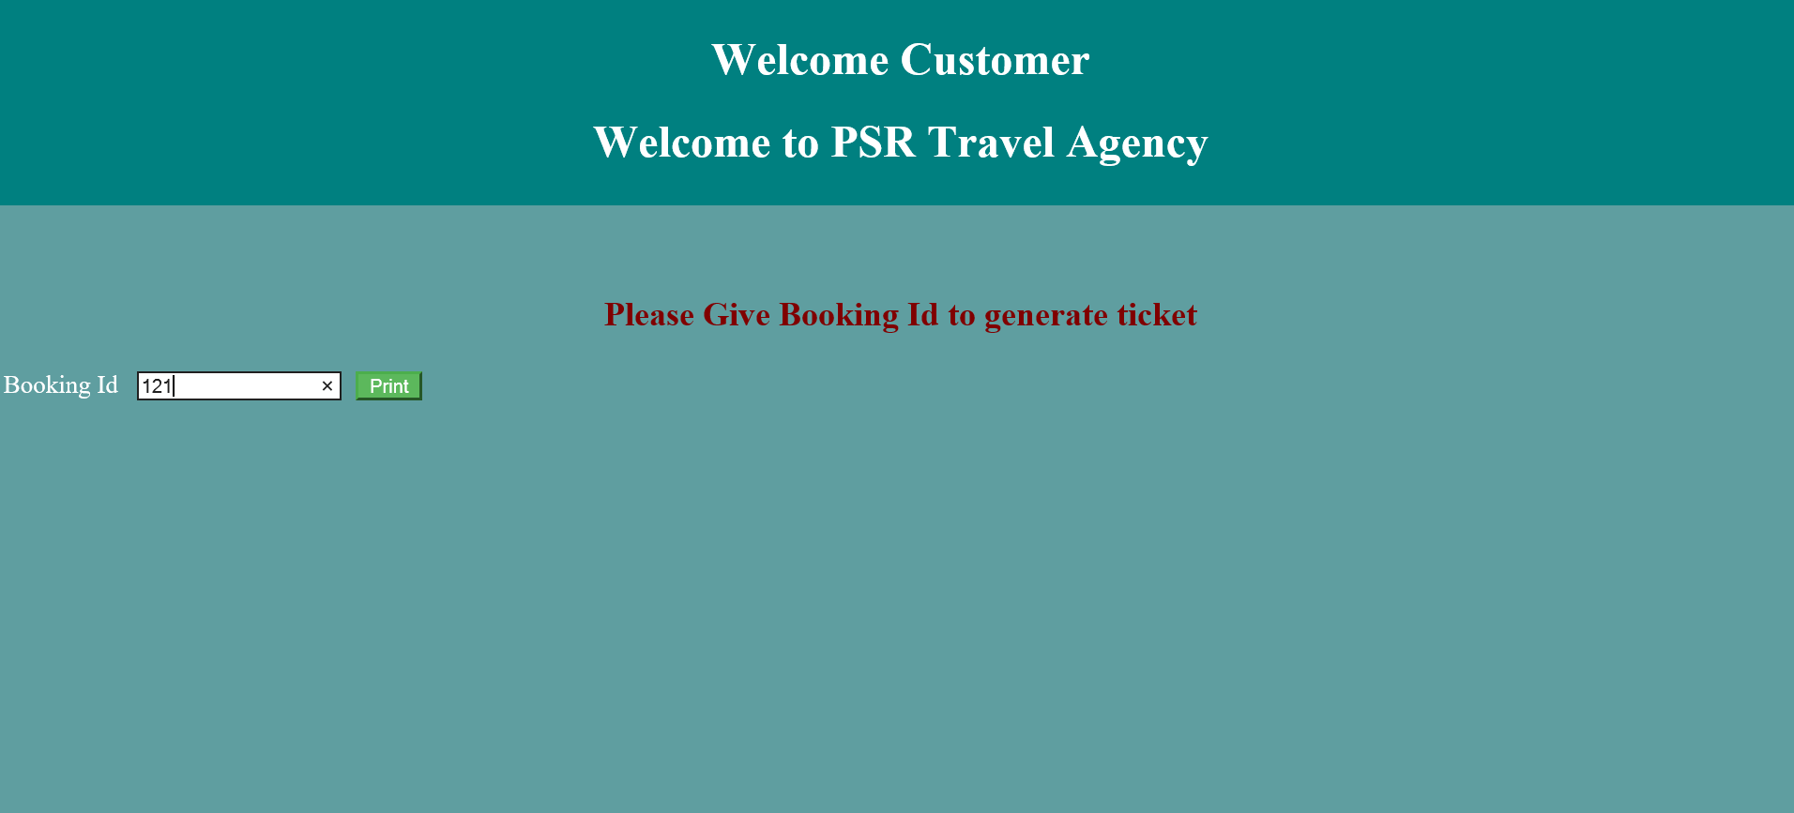

CANCEL BOOKING:

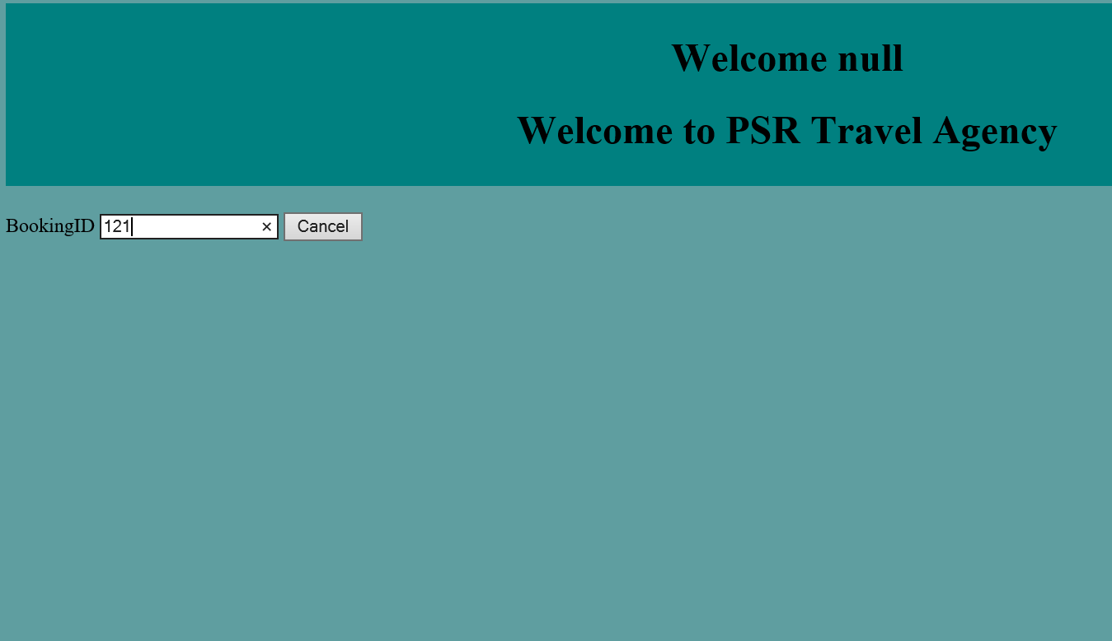

CANCEL SUCCESS:

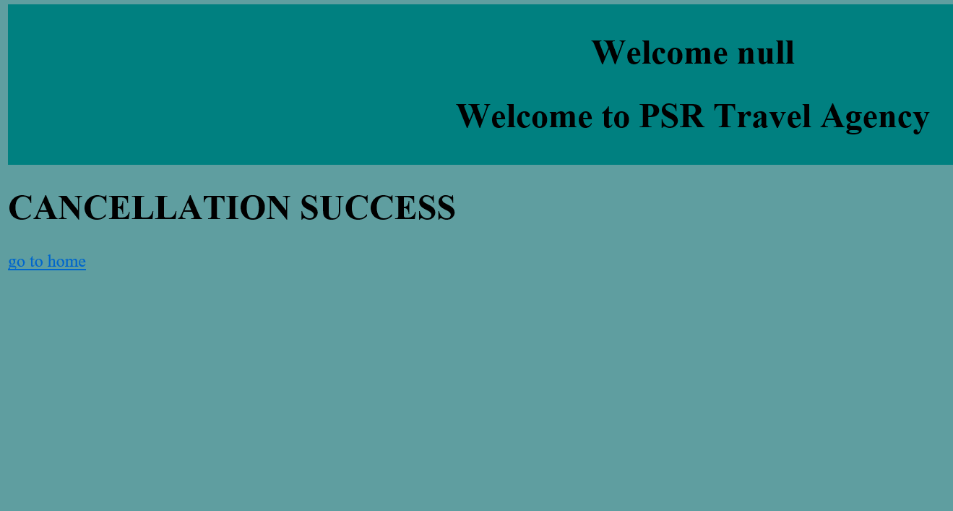

THANK

YOU